**Greener Greenham Group**



greenergreenhamgroup.org.uk



**GGG**

*“Taking care of our local environment”*

**Community Bulb Planting 2023**

**Saturday October 7th 10am**

**Meet at Stroud Green Playground**

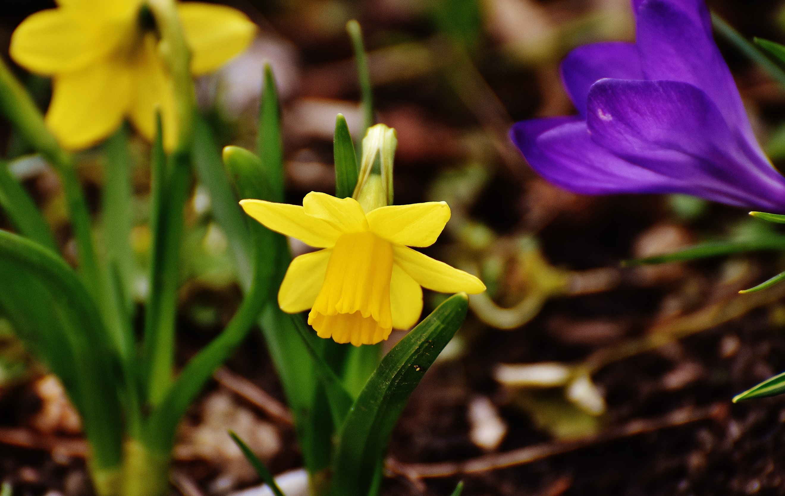

**Everyone is welcome** Refreshments provided

Bring a trowel and gloves!

ALSO

**Friday October 20th 10am**

**meet at the bench on the grassy area at the top of Pyle Hill (area called School Green).**

**This event is only suitable for adults as the planting area is close to the road.**